|  |  |
| --- | --- |
|  | **FPT ACADEMY INTERNATIONAL**  **FPT – APTECH COMPUTER EDUCATION** |

**Centre Name: ACE-HCMC-2-FPT.**

**Address: 275 Nguyen Van Dau, Binh Thanh District, Ho Chi Minh City, Viet Nam**

**Sound Blast**

|  |  |  |
| --- | --- | --- |
| **Supervisor.** | Mr. Nguyen Phat Tai | |
| **Batch.** | T1.2206.E1 | |
| **Group.** | Group 7 | |
| **Serial No.** | **Enrollment Number** | **Student Name** |
| 1. | Student1387802 | Nguyen Vu Thanh |
| 2. | Student1387832 | Cao Tien Nam |
| 3. | Student1387827 | Truong Ngo Manh Dan |

Month 09 Year 2022

**This is to certify that**

**Mr.:**

Nguyen Vu Thanh

Cao Tien Nam

Truong Ngo Manh Dan

**has successfully designed & developed**

eProject: Sound Blast website

**Submitted by: Truong Ngo Manh Dan**

**Date of issue: 11-Oct-2022**

**Authorized Signature: Dan**

**TABLE OF CONTENTS**

ACKNOWLEDGEMENT 3

SYNOPSIS 3

PROBLEM DEFINITION 3

CUSTOMER'S REQUIREMENTS SPECIFICATIONS (CRS) 3

Business/Project Objective: 3

Hardware/ Software Requirements: 4

SCOPE OF THE WORK (IN BRIEF) 5

Architecture and design of the system 6

Diagram of the website 7

TASK SHEET REVIEW 1 8

SITE MAP 9

MOCK OF THE WEBSITE 10

**1.** **HOMEPAGE** 11

**2.** **TOP ARTIST** 12

**3.** **CONTACT US** 13

**4.** **ABOUT US** 13

TASK SHEET REVIEW 2 14

WEBSITE DESCRIPTION

**1.** **HOME PAGE:**

**2.** **LATEST ALBUMS**

**3.** **ABOUT US**

**4.** **CONTACT US**

TASK SHEET REVIEW 3 22

# ACKNOWLEDGEMENT

Regarding to the Sound Blast project, we Group 7 would like to express our deepest appreciation to our teacher, Mr. Nguyen Phat Tai for his support and enthusiasm. It would not have been completed without his wise advices throughout the process of doing it. The outcome is also the proof of the hard work and effort of all the members of the group. We believe that it still needs to be improved since this is the very first project that we have participated so far and we are looking forward to receiving all the comments. Sound Blast website project is certainly a remarkable milestone in our carriers of pursuing the dream of becoming professional developpers. Last but not least, we share this goal with our families for all the unconditional love and motivation that they have given to us.

# SYNOPSIS

Sound Blast is into selling musics and posting about musics, albums, artists. Company has been selling these products for last 20 years. They have a wide range of genres. The company advertises by distributing the pamphlets, advertising on television and so on. Due to rapid development in internet field, the company decides to launch a website where people will get all the information about the various products available with them easily.

# PROBLEM DEFINITION ( watch via Problem Statement soundblast.doc )

The Web site is to be created based on the following requirements.

1. Home Page should contain logo of the site with proper sections and details of Appliances with suitable images.
2. The site should display a menu which will contain the options for brief introduction about the various appliances available, location of the shop and any other information if required.
3. The information should be categorized according to the genres of songs like if a User wants to see only “Rock” songs or any other genres then he/she can click on a Link/button/menu etc and can see only that genre products.
4. Another category option for different appliances, like ‘Top Chart’, ‘Top Artist’,.. etc. should be displayed top trending songs or artist on that time.
5. Show all albums and when a user selects any particular song from specific album, a list of all songs on that albums will be displayed
6. A brief summary of features Artist’s photos will be showed on Gallery.
7. There should be a “Contact Us” page which will have the Address of the Company which is as follows and the mail address which when clicked will invoke the local mail client from where they can send an email. Address of the Company should be displayed using GeoLocation API (eg. GoogleMaps).

# CUSTOMER'S REQUIREMENTS SPECIFICATIONS (CRS)

**Client: SoundBlast**

### Business/Project Objective:

The Objective of this program is to give a sample project to work on real life projects. These applications help you build a larger more robust application.

The objective is not to teach you JavaScript/Dreamweaver but to provide you with a real life scenario and help you create basic applications using the tools.

You can revise the chapters before you start with the project.

This project is meant for students who have completed the module of ***HTML5.*** These programs should be done in the Lab sessions with assistance of the faculty if required.

It is very essential that a student has a clear understanding of the subject. Students should go through the project and solve the assignments as per requirements given.

Kindly get back @ [eprojects@aptech.ac.in](mailto:eprojects@aptech.ac.in) in case of any doubts regarding the application or its objectives.

**Input to the system:**

* + - * Browsing products based on brands, type of appliances..

**Output from the system:**

* A menu that will categorize all the functions of the site.
* Display the list of available albums category wisely.
* Show trending songs and artists every week.
* Providing latest Artist’s gallery
* Display the list of music’s genre
* Site should be able to provide brief introduction/history about the company under About Us page.
* The location of the company is in Contact Us page.
* Besides the above requirements, the site should have look and feel as per the entertainment website standards.

**Expected delivery date:** 11-Oct-2022.

**List of deliverables:**

* + - * Document Word.
      * User Guide.
      * Source code.
      * Video Clip

### Hardware/ Software Requirements:

**Hardware**

* + A minimum computer system that will help you access all the tools in the courses is a Pentium 166 or better.
  + 64 Megabytes of RAM or better.

**Software**

* + Notepad/HTML editor.
  + Dreamweaver, VisualStudioCode.
  + IE 5.0/ Netscape 6.0.

# SCOPE OF THE WORK (IN BRIEF)

**The team has discussed and has agreed about the website layout as shown briefly below:**

1. **Homepage**: Showing brief introduction about the company and entertainment category
2. **Albums**: Containing all albums categorized by alphabet.
3. **Genres**: Containing all songs categorized by genres.
4. **Top Artist**: Showing the list of top listening artists.
5. **Top Chart**: Showing the list of top listening songs.
6. **Gallery**: Containing celebrity’s photoshoot and albums’s cover.
7. **About Us**: Introducing the history, archivements and further information about the company.
8. **Contact Us**: Dislay information about company : ceo, founder, phone number, address.

# Architecture and design of the system

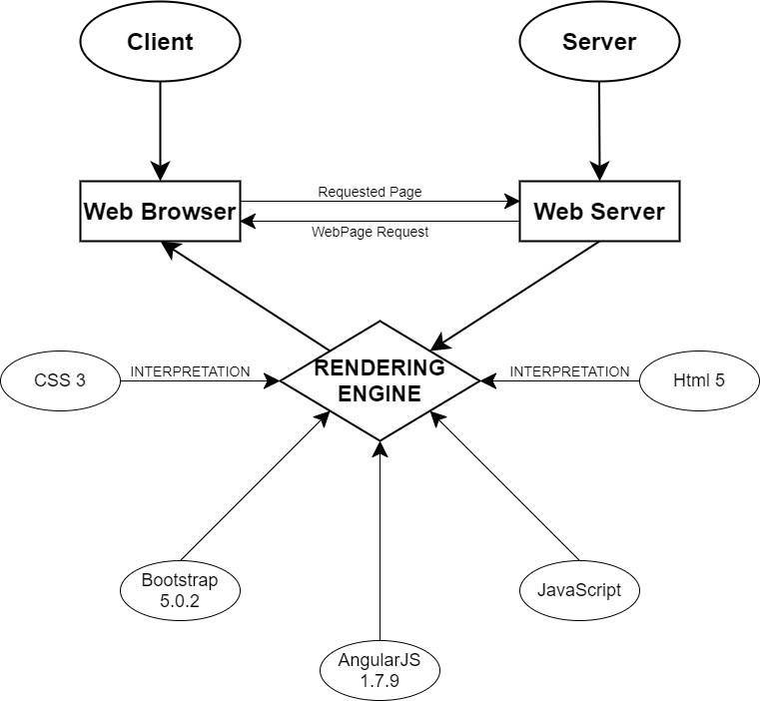

# Diagram of the website

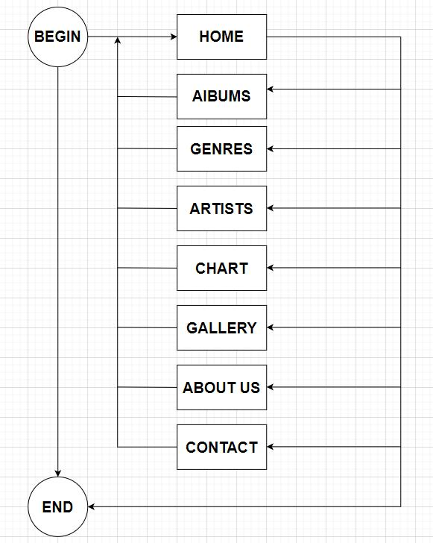



# TASK SHEET REVIEW 1(.)

|  |  |  |  |  |  |  |  |
| --- | --- | --- | --- | --- | --- | --- | --- |
| **Project Ref. No.:**  **eP/Advertisement Portal Management**  **System/01** | | **Project Title:** | **Activity Plan Prepared By:** | **Date of Preparation of Activity Plan:** | | | |
| **Sr.**  **No.** | **Task** | **Actual**  **Start Date** | **Actual Days** | **Team**  **Mate Names** | **Status** |
| 1 | Problem Statement | Sound Blast | Dan | 18-Sep-2022 | 1 | Nam, Thanh, Dan | Completed |
| 2 | Analysis of the requirements about the website | 18-Sep-2022 | 1 | Nam, Thanh, Dan | Completed |
| 3 | The scope of the work (in brief) | 18-Sep-2022 | 1 | Nam, Thanh, Dan | Completed |
| 4 | Architecture and design of the system | 18-Sep-2022 | 1 | Nam, Thanh, Dan | Completed |
| 5 | Diagram of the website | 18-Sep-2022 | 1 | Nam, Thanh, Dan | Completed |
| 6 | Task Sheet | 18-Sep-2022 | 1 | Nam, Thanh, Dan | Completed |

|  |  |
| --- | --- |
| **Date: 20/09/2021** | |
| Signature of Instructor:  **Mr. Nguyen Phat Tai** | Signature of Team Leader:    **Mr.Truong Ngo Manh Dan** |

# 

# SITE MAP

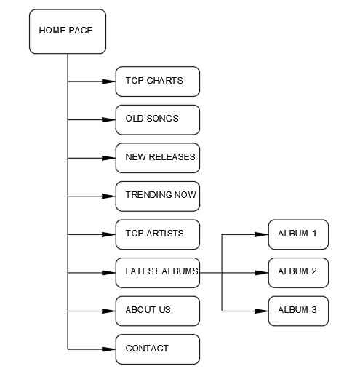

# MOCK OF THE WEBSITE

1. **HOMEPAGE**

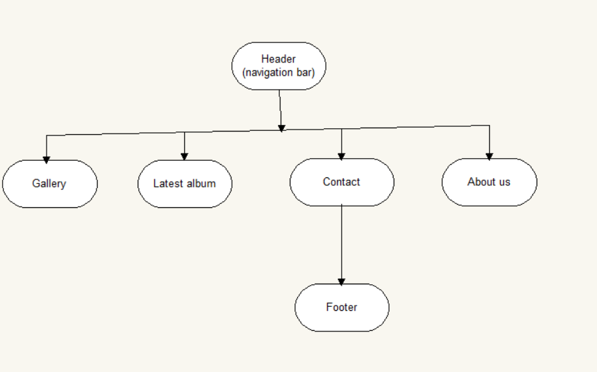

1. **Latest Album**

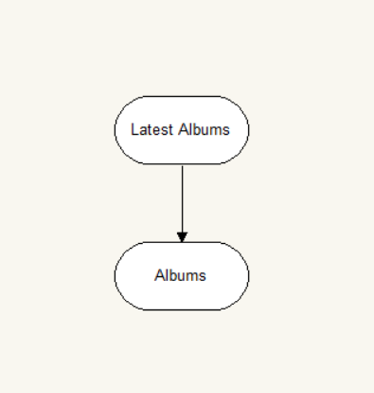

1. **CONTACT US**

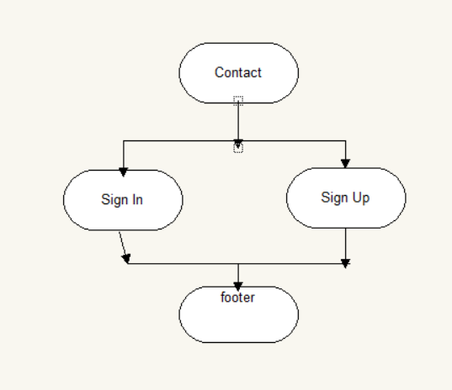

1. **ABOUT US**

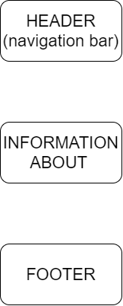

# 

# TASK SHEET REVIEW 2

|  |  |  |  |  |  |  |  |
| --- | --- | --- | --- | --- | --- | --- | --- |
| **Project Ref. No.:**  **eP/Advertisement**  **Portal Management System/01** | | **Project Title:** | **Activity Plan Prepared By:** | **Date of Preparation of Activity Plan:** | | | |
| **Sr.**  **No.** | **Task** | **Actual**  **Start Date** | **Actual Days** | **Team**  **Mate Names** | **Status** |
| 1 | Site map | Sound Blast | Dan | 20-Sep-2022 | 1 | Dan, Nam, Thanh | Completed |
| 2 | Mock of the website | 20-Sep-2022 | 1 | Danh, Nam, Thanh | Completed |
| 3 | Task Sheet | 20-Sep-2022 | 1 | Dan, Nam, Thanh | Completed |

|  |  |
| --- | --- |
| **Date: 30/09/2022** | |
| Signature of Instructor:  **Mr. Nguyen Phat Tai** | Signature of Team Leader:  **Mr. Truong Ngo Manh Dan** |

# WEBSITE DESCRIPTION

1. **HOME PAGE:**

* Description

Home page displays following information:

* Slideshows of trending songs and top artists.
* Navigation Bars
* Categorized playlists on left side including Top chart, new releases, oldsongs
* Screenshot

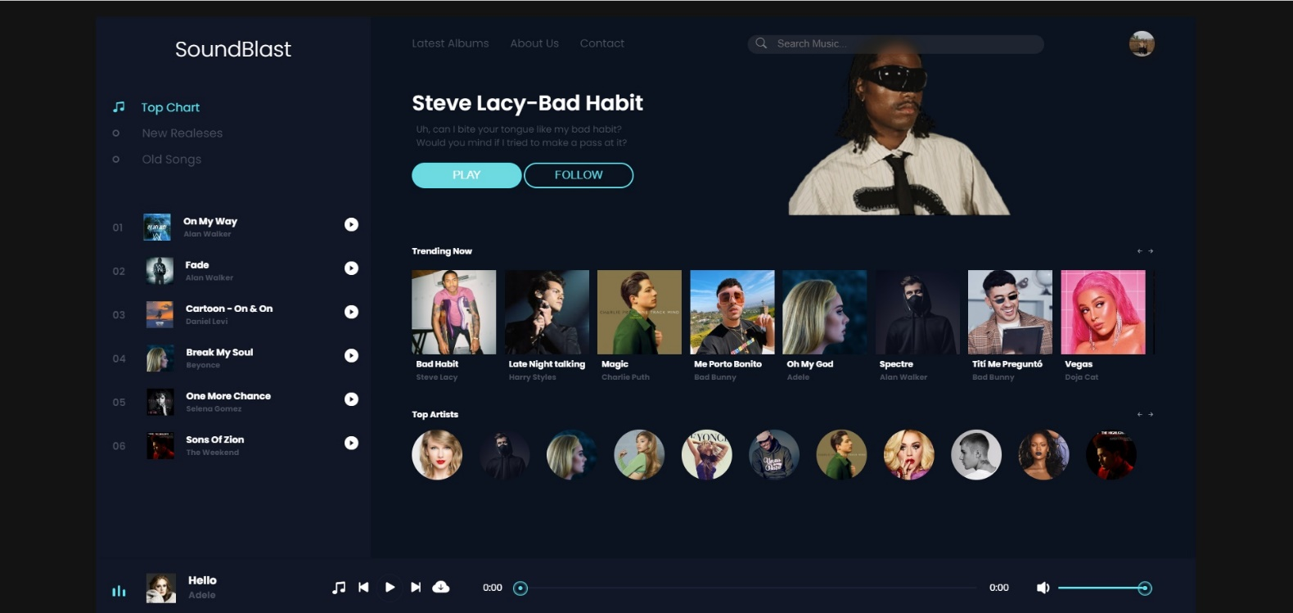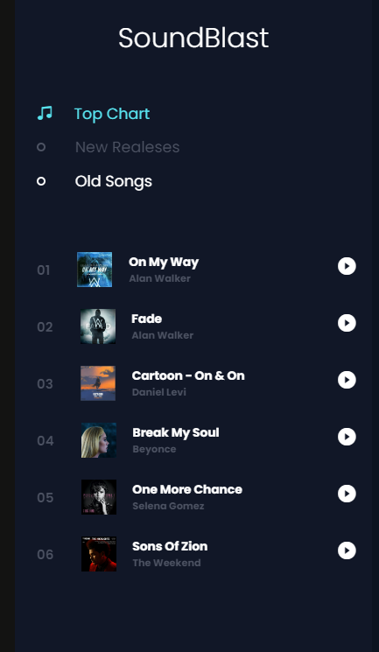

1. **Latest Album:**

* Description

This page contains albums and songs inside them

* Screenshot

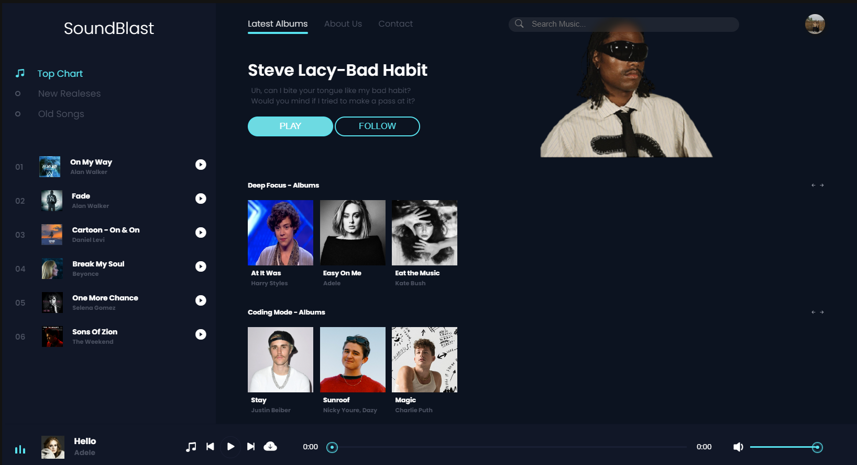

1. **About us:**

* Description:

This page contains Sound Blast ‘s information and Gallery

* Screen shot

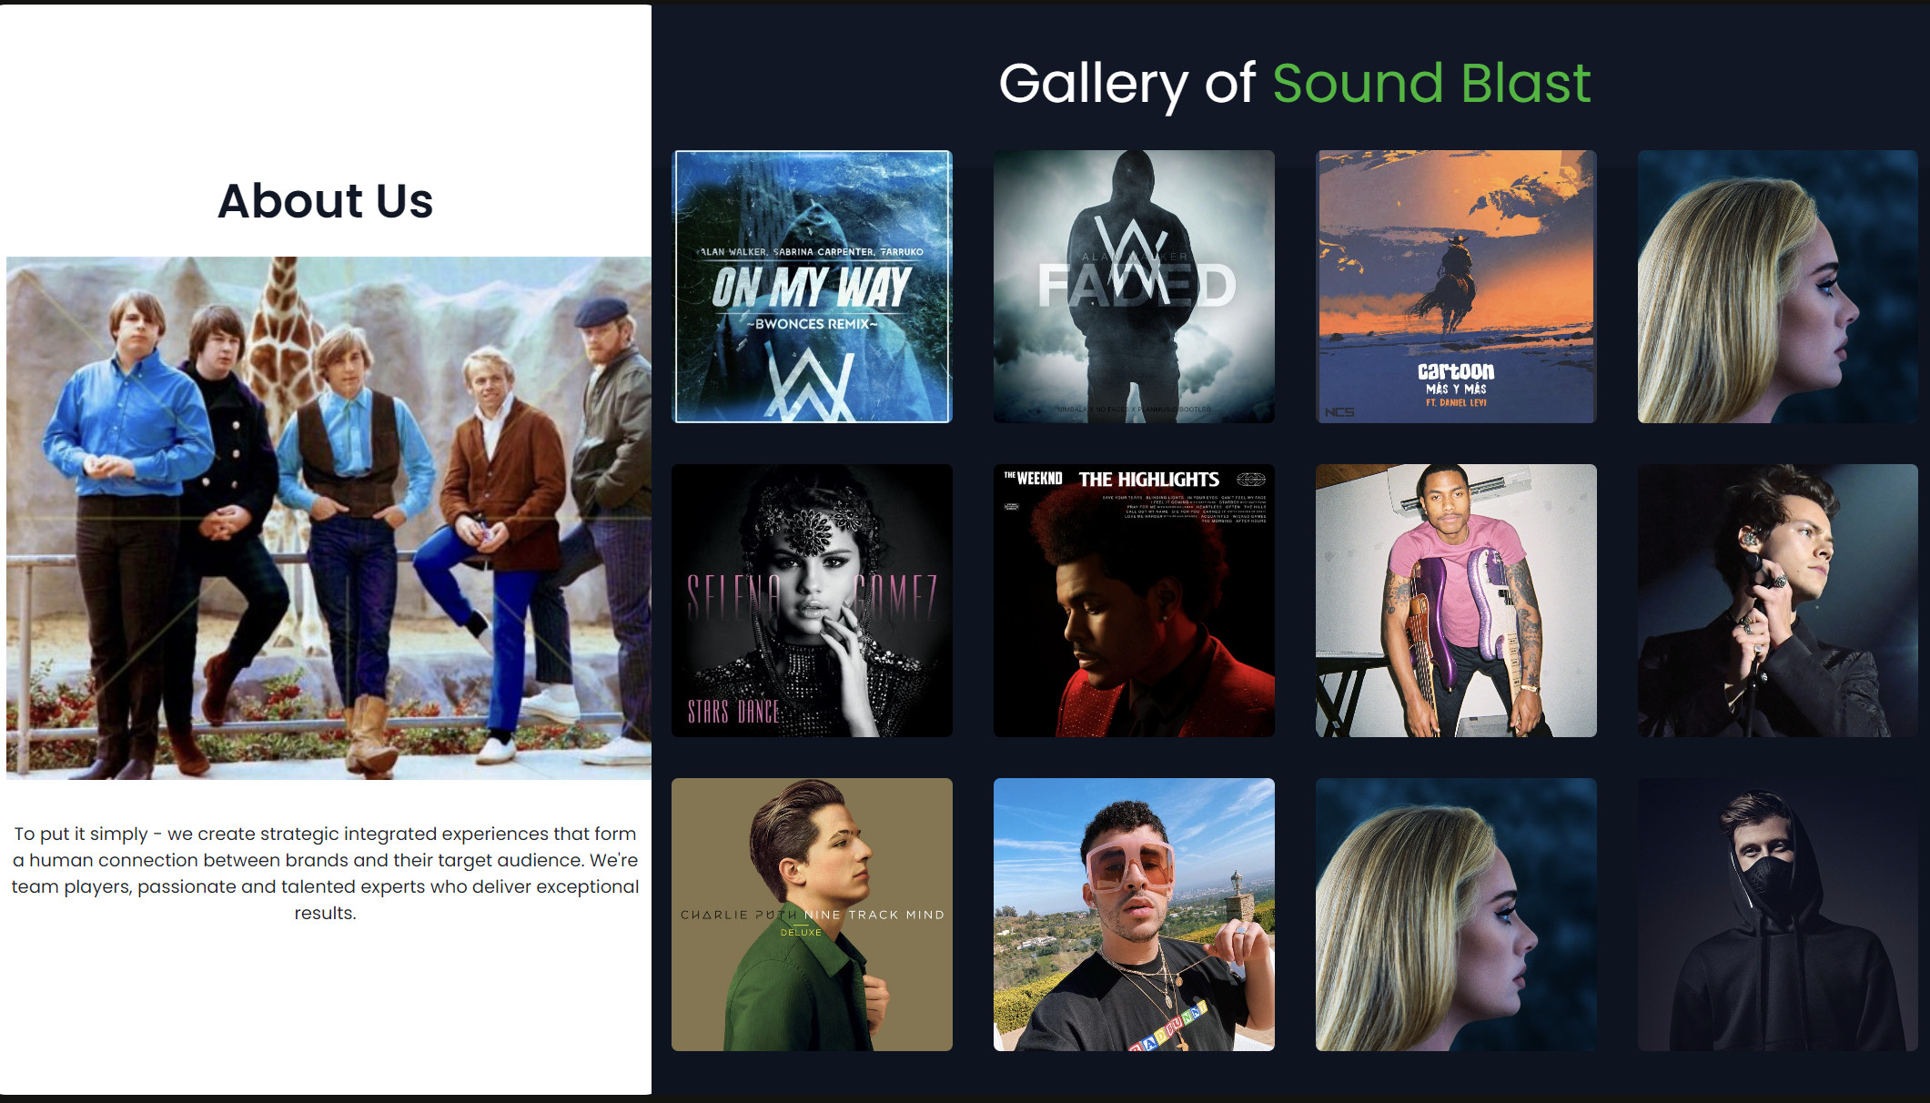

1. **Contact Us:**

* Description:

Contains company’s addresses, footer and sign in/sign up options

* Screen shot

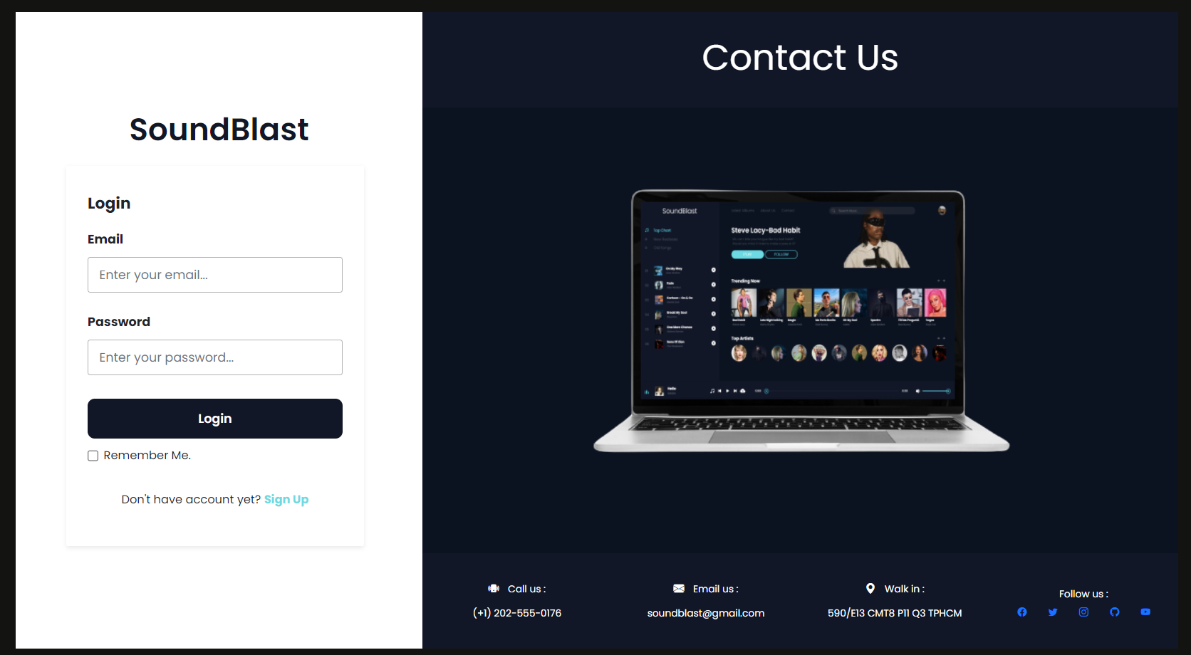

**HTML, CSS, JAVASCRIPT DESCRIPTION**

# Homepage

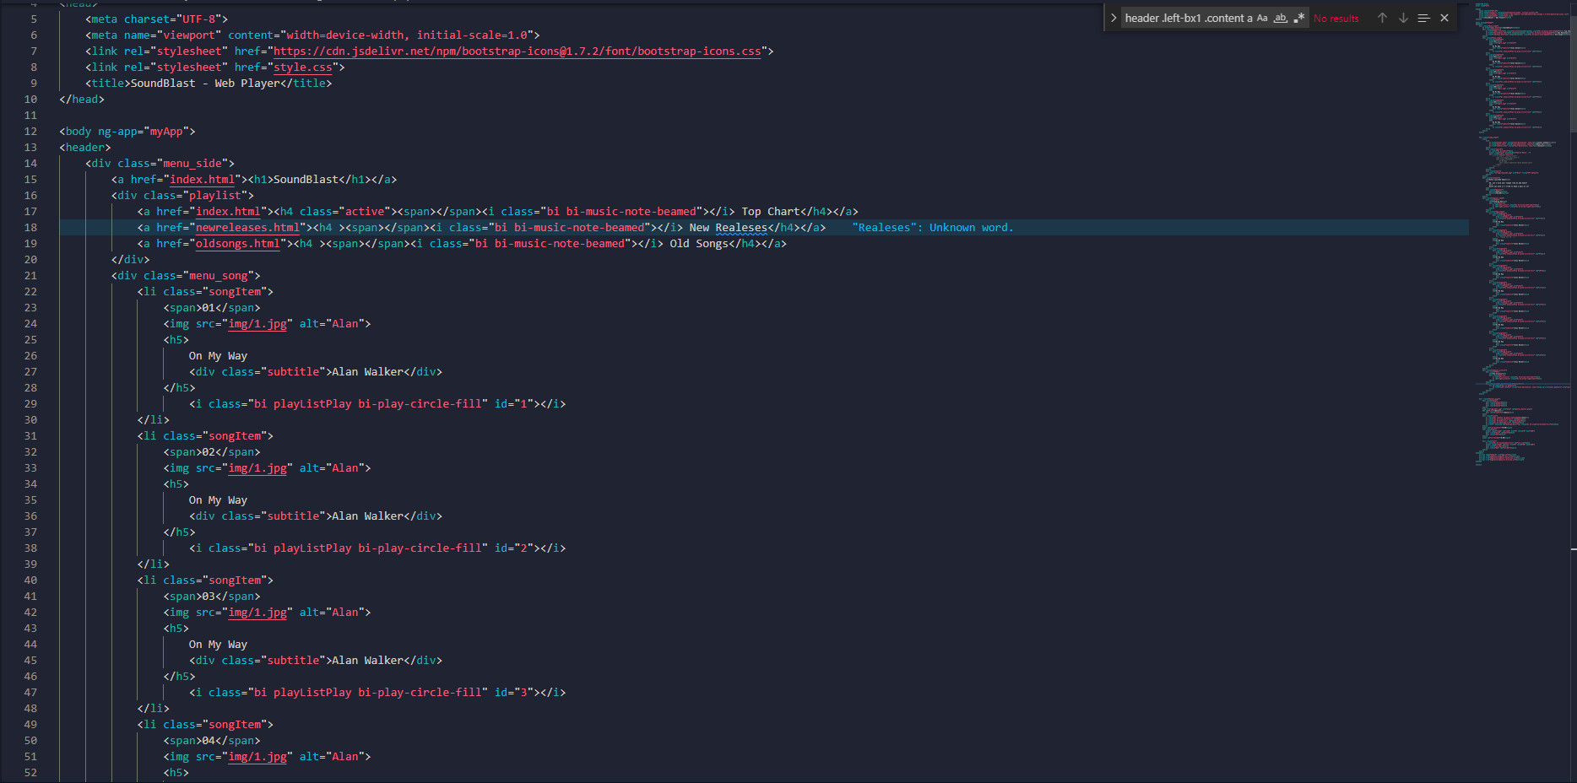

# 2.Contact us

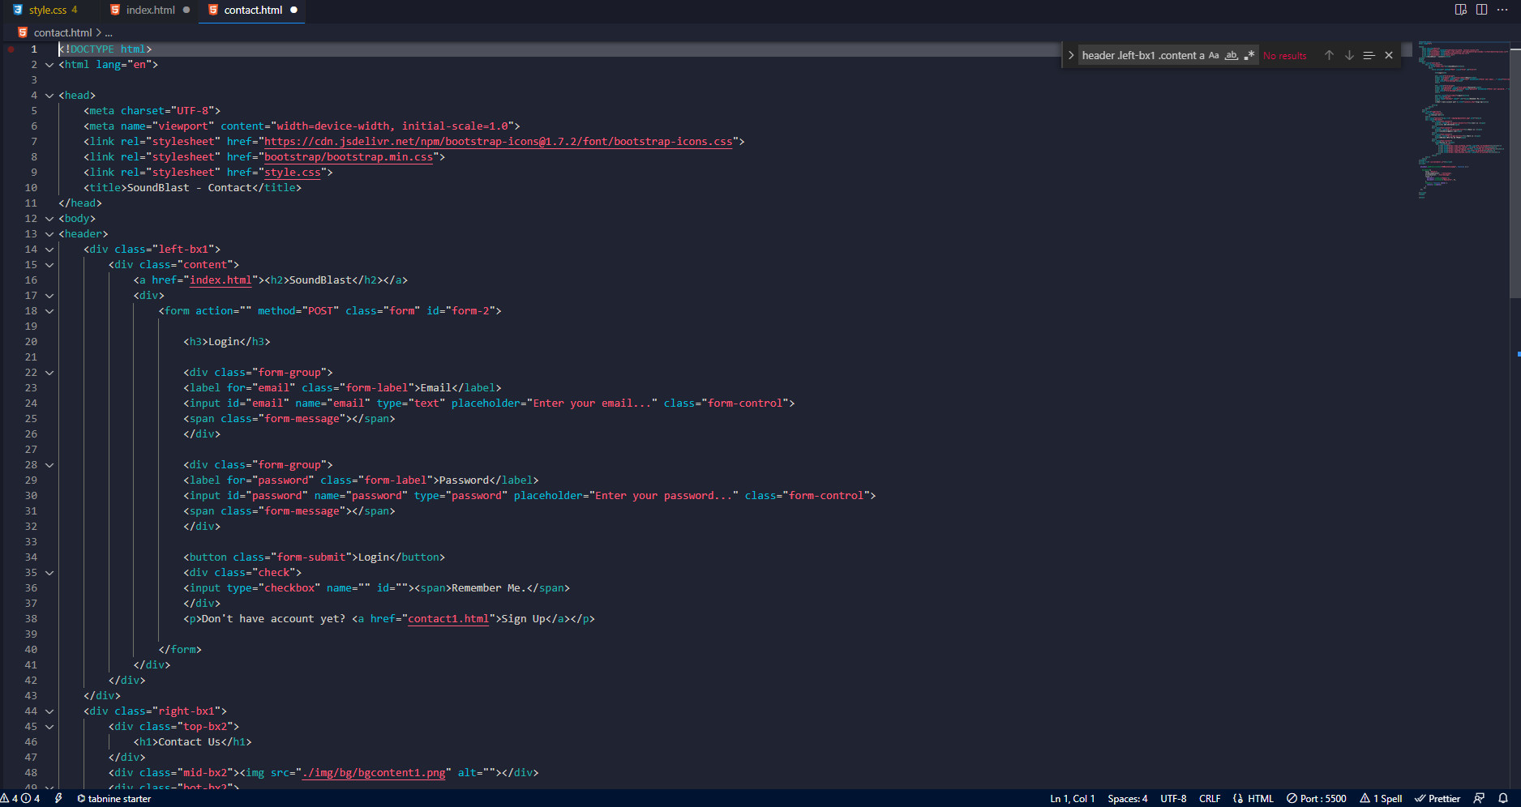

# 

# 3.About us

# 

# 

# 4.CSS

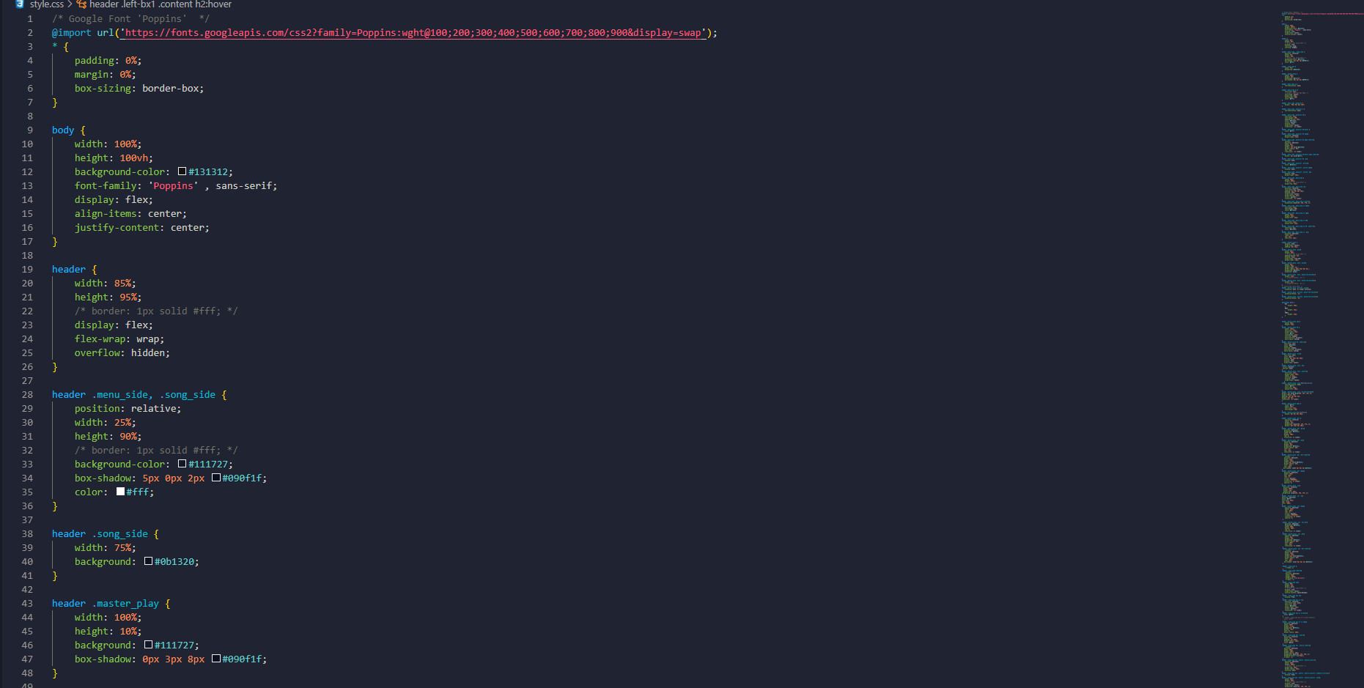

# 5.Java

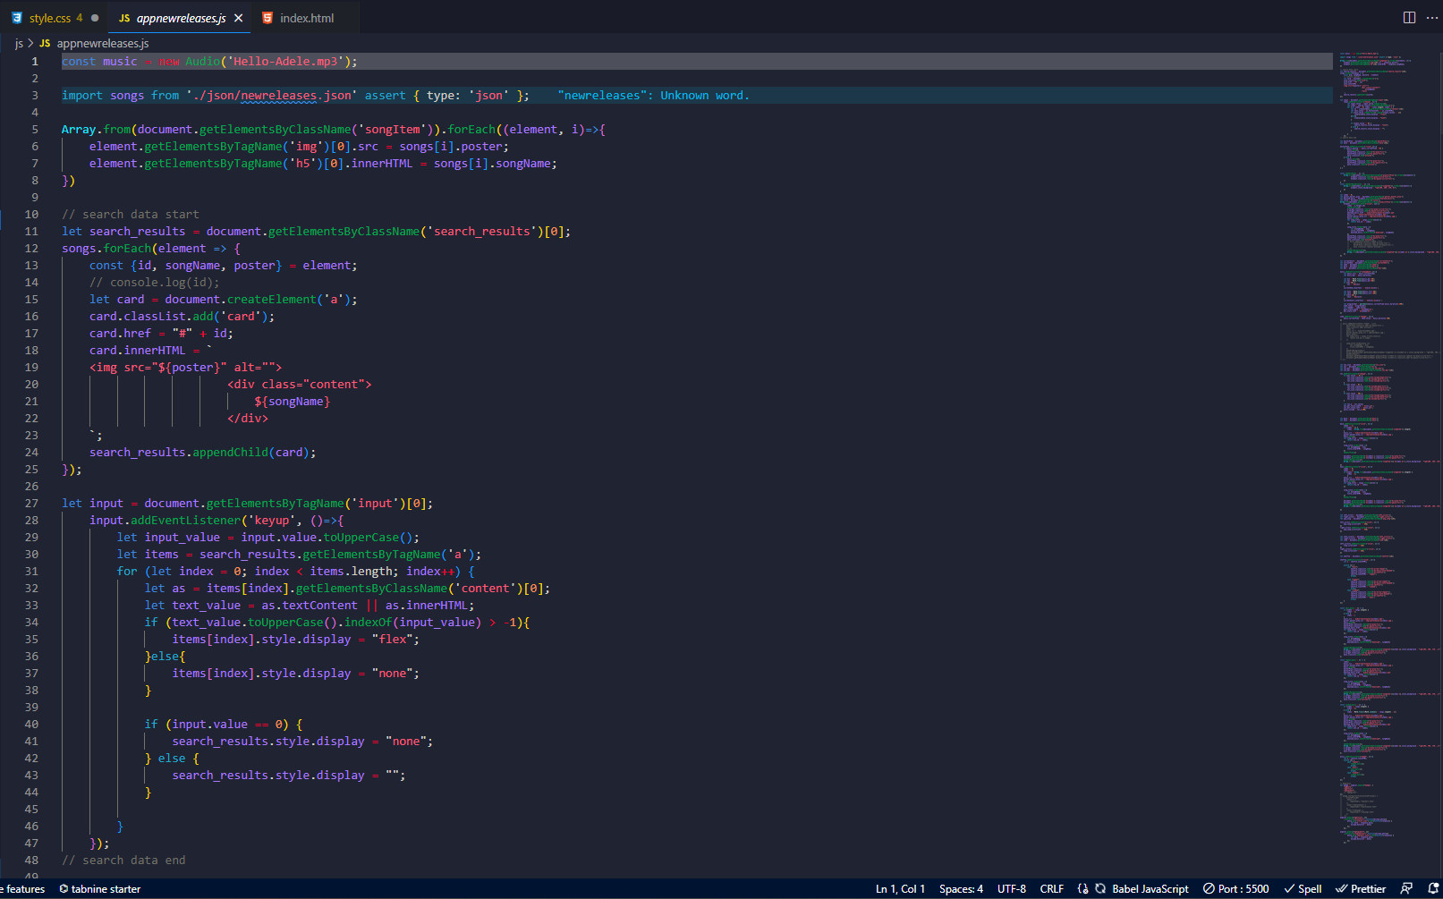

# 6.Json

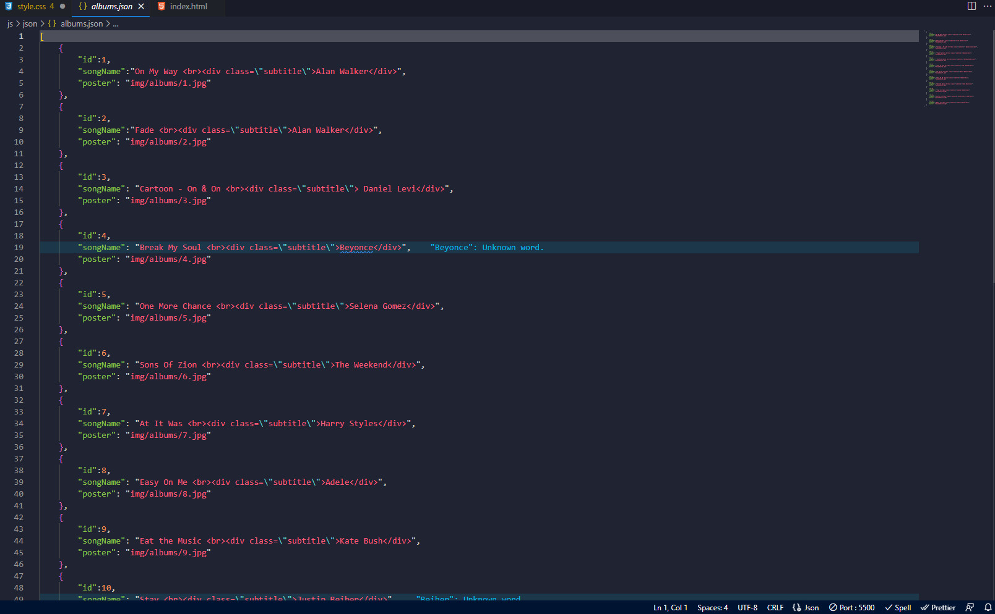

# TASK SHEET REVIEW 3

|  |  |  |  |  |  |  |  |
| --- | --- | --- | --- | --- | --- | --- | --- |
| **Project Ref. No.:**  **eP/Advertisement**  **Portal Management System/01** | | **Project Title:** | **Activity Plan Prepared By:** | **Date of Preparation of Activity Plan:** | | | |
| **Sr.**  **No.** | **Task** | **Actual**  **Start Date** | **Actual Days** | **Team**  **Mate Names** | **Status** |
| 1 | Home page | Sound Blast | Dan | 20-Sep-2022 | 1 | Thanh,Nam,  Dan | Completed |
| 2 | Latest Album | 25-Sep-2022 | 1 | Thanh,Nam,  Dan | Completed |
| 3 | About us | 27-Sep-2022 | 1 | Thanh,Nam,  Dan | Completed |
| 4 | Contact Us | 3-Oct-2022 | 1 | Thanh,Nam,  Dan | Completed |
| 5 | json | 9-Oct-2022 | 1 | Thanh,Nam,  Dan | Completed |
| 6 | Task sheet | 12-Oct-2022 | 1 | Thanh,Nam,  Dan | Completed |

|  |  |
| --- | --- |
| **Date: 12/10/2022** | |
| Signature of Instructor:  **Mr. Nguyen Phat Tai** | Signature of Team Leader:  **Mr. Truong Ngo Manh Dan** |